**SMART WATER FOUNTAINS**

**Project Objectives:**The objectives of the smart water fountain student project can be summarized as follows:

Smart Water Fountain Design: Design and build a smart water fountain that can dispense water in an automated and efficient manner.

* **IoT Integration:**

Integrate IoT (Internet of Things) technology to monitor and control the water fountain remotely .

* **Water Quality Monitoring:**

Implement sensors to monitor the quality of the water and ensure it is safe for consumption.

* **Data Logging:**

Collect and store data related to water consumption and water quality over time.

* **Mobile App or Web Interface:**

Develop a user-friendly mobile app or web interface for users to interact with and control the smart water fountain.

* **Energy Efficiency:**

Optimize the system for energy efficiency to reduce operational costs.

* **IoT Device Setup:**

The IoT device setup for the smart water fountain project involves   
 the following components:

* **Microcontroller:**

Use a microcontroller like Arduino or Raspberry Pi to control the water fountain and interface with sensors and other components.

* **Water Dispensing System**:

Design a water dispensing mechanism that can be controlled by the microcontroller, ensuring precise and controlled water flow.

* **Water Quality Sensors:**

Install water quality sensors such as pH sensors, turbidity sensors, or temperature sensors to monitor the quality of the water.

* **Flow Sensors:**

Use flow sensors to measure the amount of water dispensed.

* **Connectivity Module:**

Incorporate a Wi-Fi or cellular module to enable communication between the microcontroller and the cloud platform.

* **Power Supply:**

Provide a power source for the IoT device, which may include battery or mains power, and implement power-saving measures.

* **Platform Development:**

Developing a cloud platform to manage and control the smart water fountain is a crucial aspect of the project. This platform may involve Cloud Service: Utilize cloud services such as AWS, Azure, or Google Cloud to store data and host the application.

* **Database:**

Set up a database to store water quality data, usage statistics, and user preferences.

* **User Authentication:**

Implement secure user authentication to ensure only authorized users can control the fountain.

* **Remote Control:**

Develop an interface that allows users to remotely control the water fountain, adjust settings, and view water quality data.

* **Notifications:**

Create a system for sending notifications to users, such as low water levels, filter replacement alerts, or system updates.

**Code Implementation:**

The code implementation for the smart water fountain project involves programming the microcontroller, creating a user interface, and setting up the cloud platform. Here are some key tasks:

Microcontroller Programming: Write code to control the water dispensing system, interface with sensors, and manage the IoT connectivity.

Sensor Data Processing: Implement code to read and process data from water quality sensors and flow sensors.

IoT Communication: Set up code for sending data from the microcontroller to the cloud platform and receiving commands from the platform.

* **User Interface Development:**

Create a user-friendly mobile app or web interface to interact with the smart water fountain.

* **Data Analytics:**

Analyze and visualize the data collected from the fountain to provide insights on water usage and quality.

* **Security Measures:**

Implement security measures to protect user data and the IoT system from unauthorized access.

* **Testing and Debugging:**

Thoroughly test the system, identify and fix any bugs, and ensure it functions as intended.

* **Documentation:**   
  Document the code and system architecture for future reference and troubleshooting.

Overall, the smart water fountain student project involves designing, building, and programming a smart water fountain, integrating IoT technology, and developing a cloud-based platform for monitoring and control. The project aims to provide a convenient and efficient way users to access clean water while promoting water conservation and quality monitoring.

**1.Smart Water Fountain Components:**Microcontroller (e.g., Raspberry Pi): Central processing unit that controls the fountain and handles data.

**Water Dispensing System**: Mechanism for controlled water dispensing.Water Quality Sensors (e.g., pH, turbidity): Sensors to monitor water quality.

**Flow Sensors:** Measure water flow rate.

**Connectivity Module:** Wi-Fi or cellular module for IoT connectivity.

**Power Supply:** Battery or mains power source.

**2. Schematic Overview:**

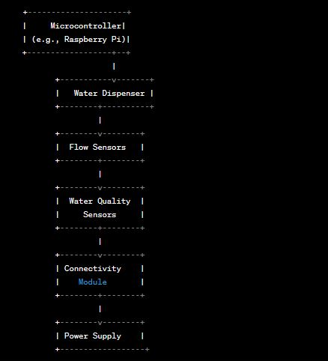

**3. Data Sharing Platform:**

To share data from your smart water fountain, you'll need a cloud-based platform. Here's how it works:

**Data Collection:** The microcontroller collects data from water quality sensors and flow sensors.

**Data Transmission:** The microcontroller sends this data to the cloud-based platform via the IoT connectivity module (Wi-Fi, cellular, etc.).

**Cloud Platform:** This platform can be hosted on a service like AWS, Azure, or Google Cloud and includes the following components:

**Database:** Stores data (e.g., water quality readings, water flow, usage statistics).

**User Authentication:** Ensures secure access to the platform.

**User Interface:** Provides a web or mobile app for users to monitor and control the smart water fountain remotely.

**Notification System:** Sends alerts and notifications to users based on the data (e.g., low water levels, filter replacement alerts).

**Data Visualization:** The data stored in the cloud platform can be visualized using tools like dashboards, graphs, or charts.

**Data Sharing:** Users can access the platform via a secure login to view real-time data and historical records of water quality and usage. They can also control the fountain remotely.

**Code implementation:**

import RPi.GPIO as GPIO

Import time

Import paho.mqtt.client as mqtt

# GPIO setup

GPIO.setmode(GPIO.BCM)

Water_pump_pin = 17

GPIO.setup(water_pump_pin, GPIO.OUT)

# MQTT setup

Mqtt_broker = “your_broker_address”

Mqtt_topic = “water_fountain/control”

Client = mqtt.Client()

# Callback for MQTT message received

Def on_message(client, userdata, message):

If message.payload.decode() == “on”:

GPIO.output(water_pump_pin, GPIO.HIGH)

Else:

GPIO.output(water_pump_pin, GPIO.LOW)

# Connect to MQTT broker

Client.on_message = on_message

Client.connect(mqtt_broker)

Client.subscribe(mqtt_topic)

Client.loop_start()

Try:

While True:

# Read water level and temperature sensors

Water_level = … # Read water level from sensor

Temperature = … # Read temperature from sensor

# Your logic for controlling the water pump based on sensor readings

If water_level < threshold:

# Water level is too low, turn off the pump

GPIO.output(water_pump_pin, GPIO.LOW)

# Publish sensor data to the MQTT broker

Client.publish(“water_fountain/data”, f”Water Level: {water_level}, Temperature:

{temperature}”)

# Add any other functionality or logic here

Time.sleep(5) # Adjust the interval as needed

Except KeyboardInterrupt:

GPIO.cleanup()

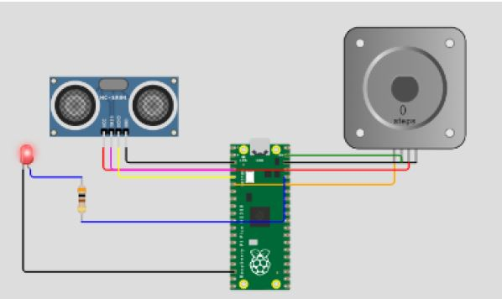

**WIRING CONNECTIONS:**

**1. Ultrasonic Sensor:**

**Purpose:** The ultrasonic sensor is used to measure water levels in the fountain.

▪ Connect the VCC (power) pin to the 5V output of the Raspberry Pi.  
▪ Connect the GND (ground) pin to a GND (ground) pin on the Raspberry Pi.  
▪ Connect the TRIG (trigger) pin to GPIO pin 17 on the Raspberry Pi.  
▪ Connect the ECHO (echo) pin to GPIO pin 18 on the Raspberry Pi.

**2. Water Pump:**

**Purpose:** The water pump controls the flow of water within the fountain.

▪ Connect the positive (red) wire of the water pump to an external power supply suitable for the pump's voltage and current requirements.  
▪ Connect the negative (black) wire of the water pump to the collector (C) of an NPN transistor or use a motor driver module to control the pump.  
▪ Connect the emitter (E) of the transistor to the GND (ground) of the Raspberry Pi.  
▪ Connect the base (B) of the transistor to GPIO pin 4 on the Raspberry Pi through a current-limiting resistor (220-330 ohms).

**3. LED (with Resistor):**

**Purpose:** The LED serves as a visual indicator of the water level.

▪ Connect the longer leg (anode) of the LED to a current-limiting resistor (220-330 ohms).  
▪ Connect the other end of the resistor to GPIO pin 5 on the RaspberryPi.  
▪ Connect the shorter leg (cathode) of the LED directly to a GND (ground) pin on the Raspberry Pi.

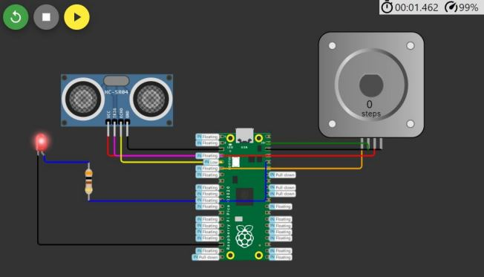

**CODE DESCRIPTION:**

import time

TRIG_PIN = 2

ECHO_PIN = 3

PUMP_PIN = 4

LED_PIN = 5

ultrasonic_sensor = Ultrasonic(TRIG_PIN, ECHO_PIN)

pump = Motor(PUMP_PIN)

led = LED(LED_PIN

while True:

distance = ultrasonic_sensor.distance_cm

if distance > 200:

led.blink(on_time=0.5, off_time=0.5)

pump.on() # Water pump is turned on

else:

led.off()

pump.off()

time.sleep(0.1)

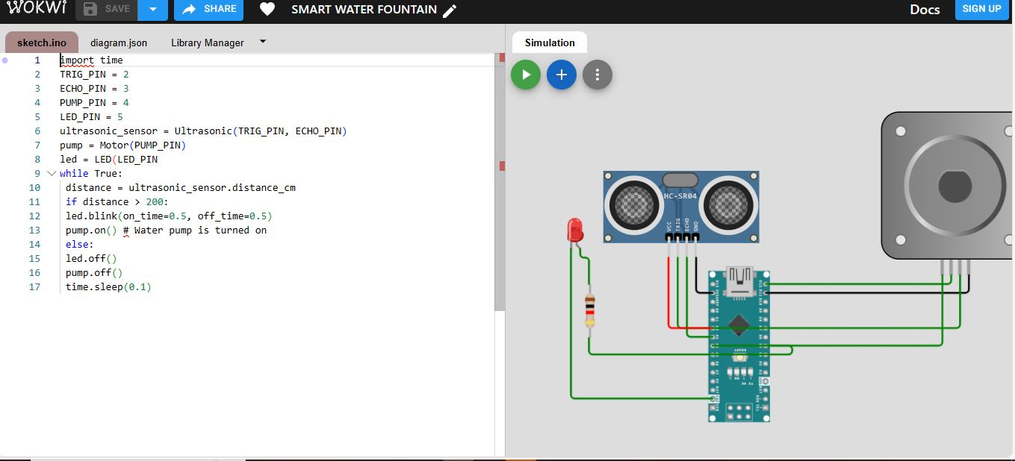

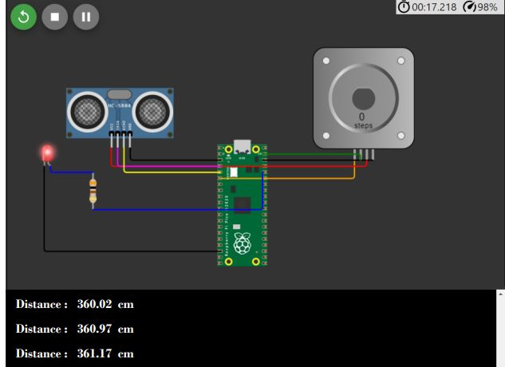

**VISUAL STUDIO CODE:**

